Driver model

# 1 System description

Model of the driver. The driver gives basic orders and follows a driving cycle (speed reference). The basic model includes the NEDC cycle references.

# 2 System organization

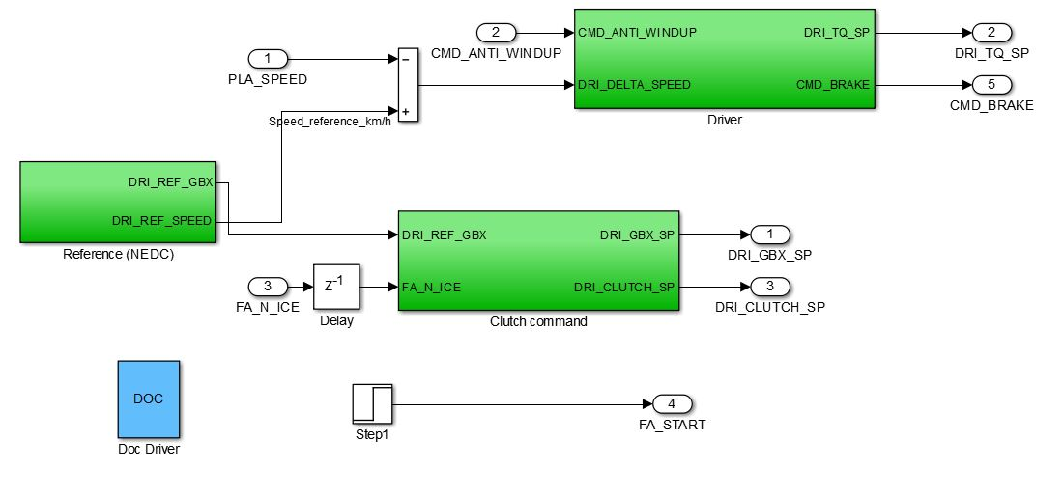

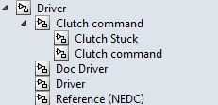

# 3 Signals and parameters

## Inputs

|  |  |  |
| --- | --- | --- |
| Name | Description | Note |
| PLA_SPEED | Car speed | In km/h |
| CMD_ANTI_WINDUP | Input for the anti windup setting for the driver corrector | - |
| FA_N_ICE | Rotation speed of the ICE | rpm |

## Outputs

|  |  |  |  |
| --- | --- | --- | --- |
| Name | Description | Note | Destination |
| DRI_TQ_SP | Torque request from the driver | - | Command, |
| DRI_CLUTCH_SP | Clutch pedal value | Range [0, 1] | Command, front axle |
| DRI_GBX_SP | Gearbox engaged gear | For a manual gearbox | Command, front axle |
| DRI_CMD_BRAKE | Brake request from the driver | Torque N.m | Command |
| FA_START | Request of starting ICE | binary | Command |

## Parameters

### Native

|  |  |  |  |  |  |
| --- | --- | --- | --- | --- | --- |
| Name | Type | Unit | Description | Source | Linked to |
| dri_cycle_speed | vector | m/s | cartonedc | Continental | dri_cycle_time |
| dri_cycle_time | vector | s | cartonedc | Continental | dri_cycle_speed |
| dri_gbx_sp | vector | - | cartonedc | Continental | dri_gbx_time |
| dri_gbx_time | vector | s | cartonedc | Continental | dri_gbx_sp |
| dri_ki | var | - | Driver corrector parameter | BEI N7 2014 |  |
| dri_kp | var | - | Driver corrector parameter | BEI N7 2014 |  |

# 4 Subsystems description

Reference (NEDC):

Provide the speed reference and the gear reference for the NEDC cycle

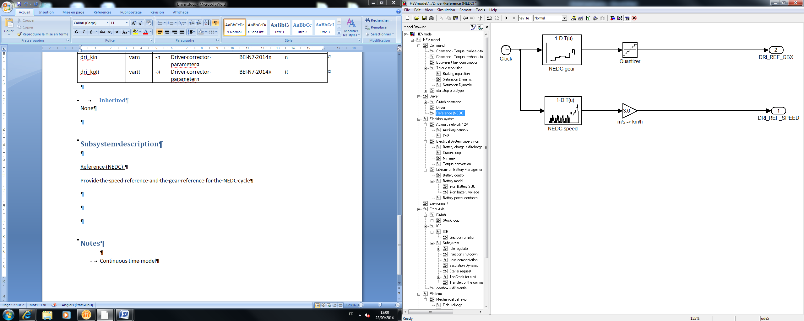

Driver:

Controller for following the speed reference. Design detailed in the BEI N7 2014.

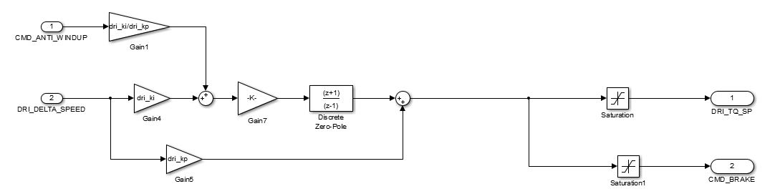

Clutch command:

Determine automatically the clutch pedal value. The clutch also is considered open when the gearbox is set at neutral and maintained open at null speed.

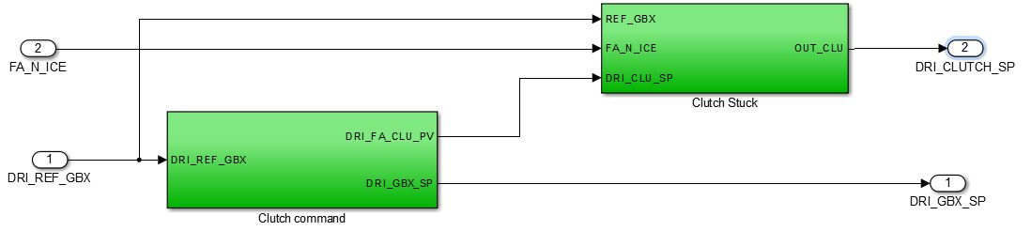

* Clutch command: determines the command of the clutch when changing gear

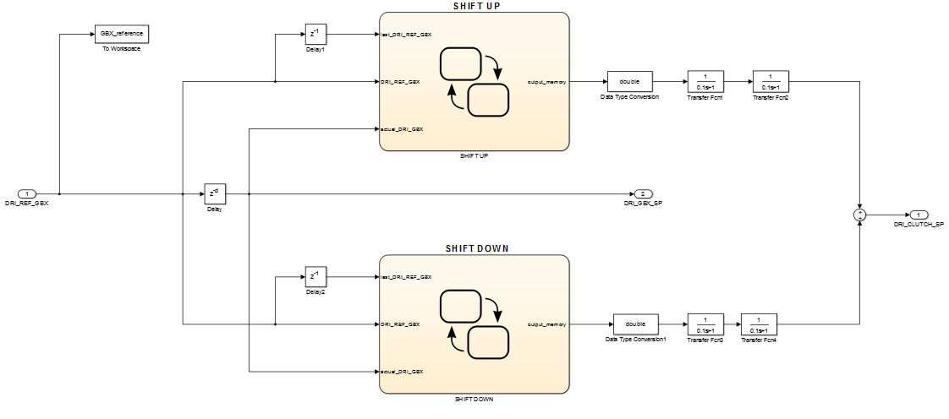

* Clutch Stuck: Avoids the clutch to be unstuck when gear is null

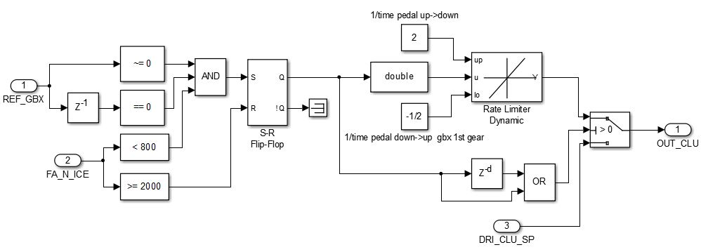

# 5 Discrete Model

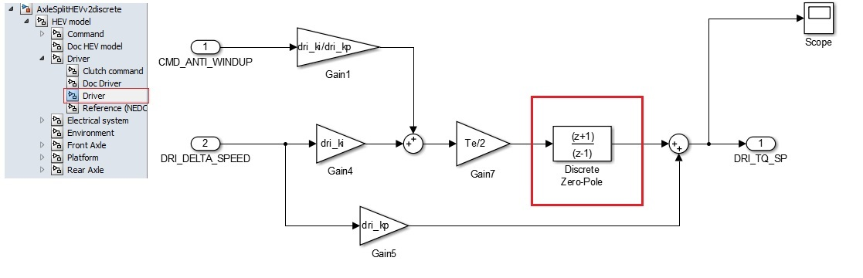

Same inputs, outputs and parameters. The only changes are in the red square.

See part 5 (“Discrete model”) of the document “HEV model” to know how are made the discrete blocs.